**UCS 2312 Data Structures Lab**

**Assignment 12: Implementation of Searching and Sorting algorithms**

The numberADT contains the size of integer array and an array of integers. [CO2, K3]

* void init(numbertADT *N) – To initialize the size of the array
* void insertElements (numberADT *N, int x[10])– To copy the elements from x to

the array in numberADT

* void insSort(numberADT *N) – Sorting of elements in the array using selection sort
* void shellSort(numberADT *N) – Sorting of elements in the array using shell sort
* void display(numberADT *N) – Display the elements in the array

Additional Routines

Write a routine in ADT to find the element that appears once in sorted array with O(log n) time complexity.

Write a routine in ADT to count the number of 1’s in sorted array with O(log n) time complexity

In your notebook, design atleast 3 test cases to realize best/worst/average cases. For each test case, trace the additional routines and write the state of the array in each iteration. Verify your expected output with the actual output of your function.

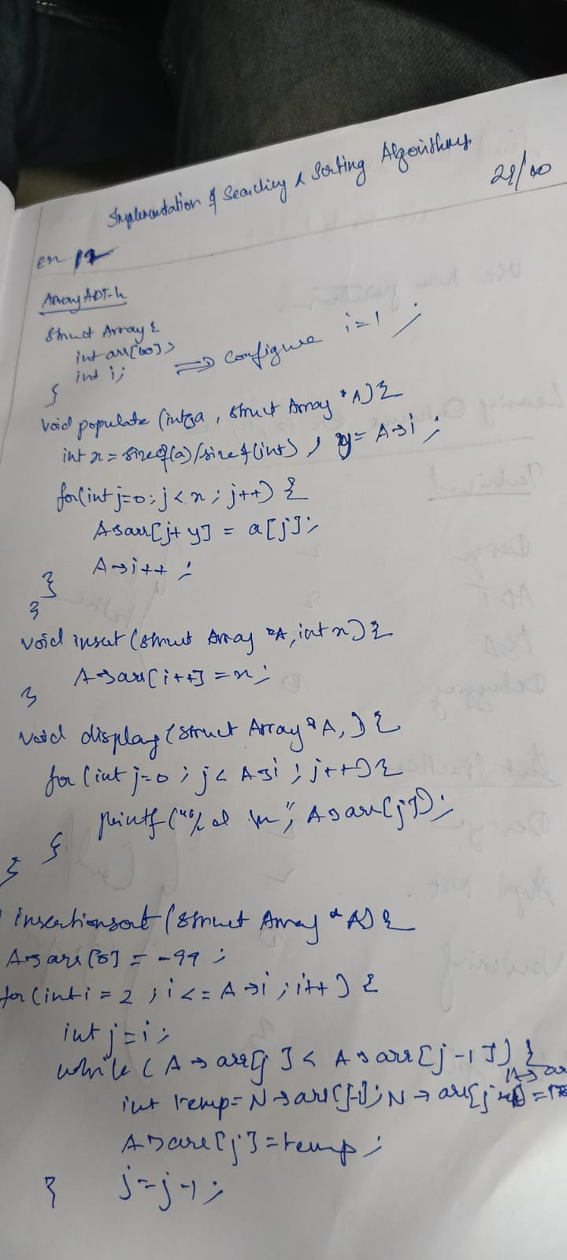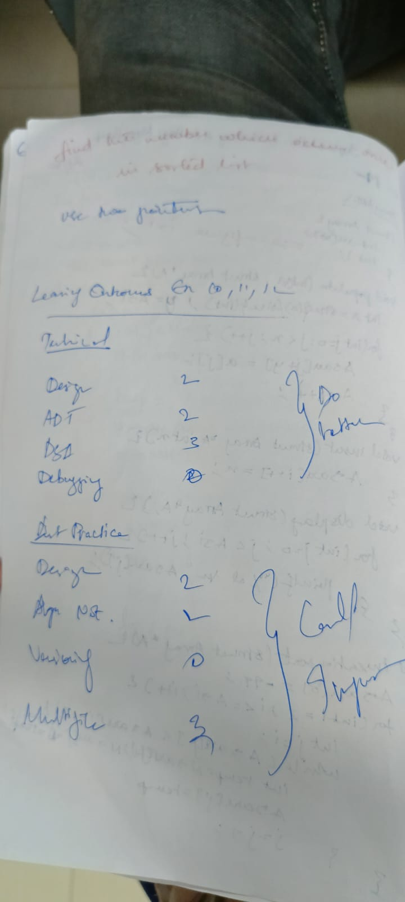

Technical Outcomes:

|  |  |  |
| --- | --- | --- |
| Design | 3 |  |
| Understanding DS | 3 |  |
| Usage of DS | 2 | Needs improvement |
| Debugging | 3 |  |

Best Practices:

|  |  |  |
| --- | --- | --- |
| Design before coding | 3 |  |
| Usage of algo | 3 |  |
| Multifile | 1 | Needs improvement |
| versioning | 3 |  |